A Route Planner for Practical Ride-Sharing Applications

Richard Webb  
Systems Engineering *Simon Fraser University*  
Vancouver, Canada  
rjwebb@sfu.ca

John (Junseong) Kim  
Systems Engineering *Simon Fraser University*  
Vancouver, Canada  
jka157@sfu.ca

Jungkyu Kim  
*Systems Engineering*  
*Simon Fraser University*Vancouver, Canada  
jkk15@sfu.ca

***Abstract*—This article describes how to use a decision agent uses our route planner program to maximize the utility. It is created to simulate real-world usage of ride-sharing platforms picking up and dropping off passengers while calculating various utilities such as distance, accidents and traffic to make the best route choice possible.**

***Keywords—Yen’s algorithm, markov chain***

# Introduction

Navigating through cities with heavy traffic due to dense populations can be stressful and time consuming. Although the transit system is well developed in most cities, it is often limiting with unexpected delays along with designated stops that isn’t convenient for everyone.

Ride-sharing platforms have become extremely popular for this exact reason, especially in big cities. Services such as Lyft and Uber, to name a few, have billions of users taking advantage of the relatively affordable and efficient ride-sharing platform. Although those applications provide intuitive solutions to their users, to further improve the pre-existing services we have developed a route planner for a wider array of applications. The decision agent will receive real-time updates for the best possible route to take with assigned utility values.

In our program, our simulation is done over a map of Vancouver and we have specifically designed our code around ride-sharing platforms such as multiple-passenger taxi services, Lyft, and Uber in mind. The utilities we considered for our program are traffic conditions, presence of passengers, route distances and presence of accidents. The goal is to maximize the number of passengers (with a maximum of 6) and drop them off as quickly and efficiently as possible.

This article will cover the possible applications of our program as it can be implemented in various different applications. In addition, we will explain the network of nodes and links we have set up for our simulation. After that, we will walk through the execution process the decision agent makes travelling from one node to the next explaining the ranking and scaling of utility values designed for our simulation. Lastly, we will demonstrate some possible features we can add to our program to further enhance the user experience and the application potential.

# Real-World Applications

Our program may seem to be designed specifically for ride-sharing platforms, however, our code is a form of a navigation system that simulates real-world traffic conditions with various utility variables. For example, Waze and Google Maps are two of the very famous applications used for real-time navigation. In Figure 1, we can see the smart implementation of real-time updates on various utilities users can take advantage of using Waze. Along with the typical direction and estimated time of arrival updates based on traffic conditions, it also provides speed limits and user-reported police updates.



1. Real-time navigation updates (*Waze example*)

Similar to Waze, we can implement a wide array of updates depending on the user’s needs. One of the possible implementations we can apply to our program is to autonomous driving. Similar to what Tesla has done with their autonomous driving systems, our program plans out the route according to the destination with various traffic conditions keeping the range it can travel in mind. Our program may be used in conjunction with autonomous driving as it plans out 20 best possible route suggestions for the user’s destinations. The autonomous driving technology will then take over and follow the best route planned out from our program with the ability to update the route if need be.

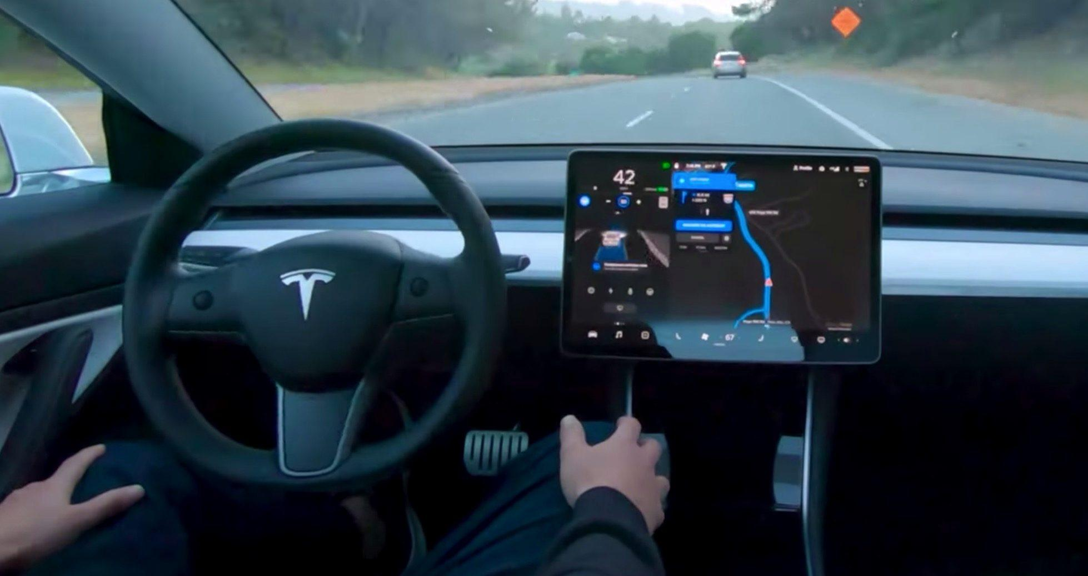

1. Tesla Autonomous Driving

Not only can our program be implemented to personal vehicles, with the improvement of technology we may see self-driving service vehicles, transit vehicles and taxis. All of these vehicles can take advantage of self-driving technology and will benefit from getting to their destinations as fast and efficiently as possible. Along with public service vehicles, our program may be implemented with business vehicles such as Uber Eats, Skip the Dishes that require maximization of utilities. The goal of these businesses is to pick up food from restaurants (similar to us picking passengers) and drop off the food to customers (dropping them off) as quick as possible. With slight modification of our code, we can easily apply our program for these businesses.

# Network Setup

As mentioned earlier, we have decided to do the simulation of our project over a map of Vancouver as we were most familiar with the area to replicate a real-world simulation of a busy city. Demonstrated in Figure 3, we have set up various nodes around Vancouver and attempted to set up nodes that were spread out and most often visited by people in the city. With enough nodes chosen on the map, we connected the nodes with bi-directional links. Each link is given approximated weight values to replicate the distance from each node.

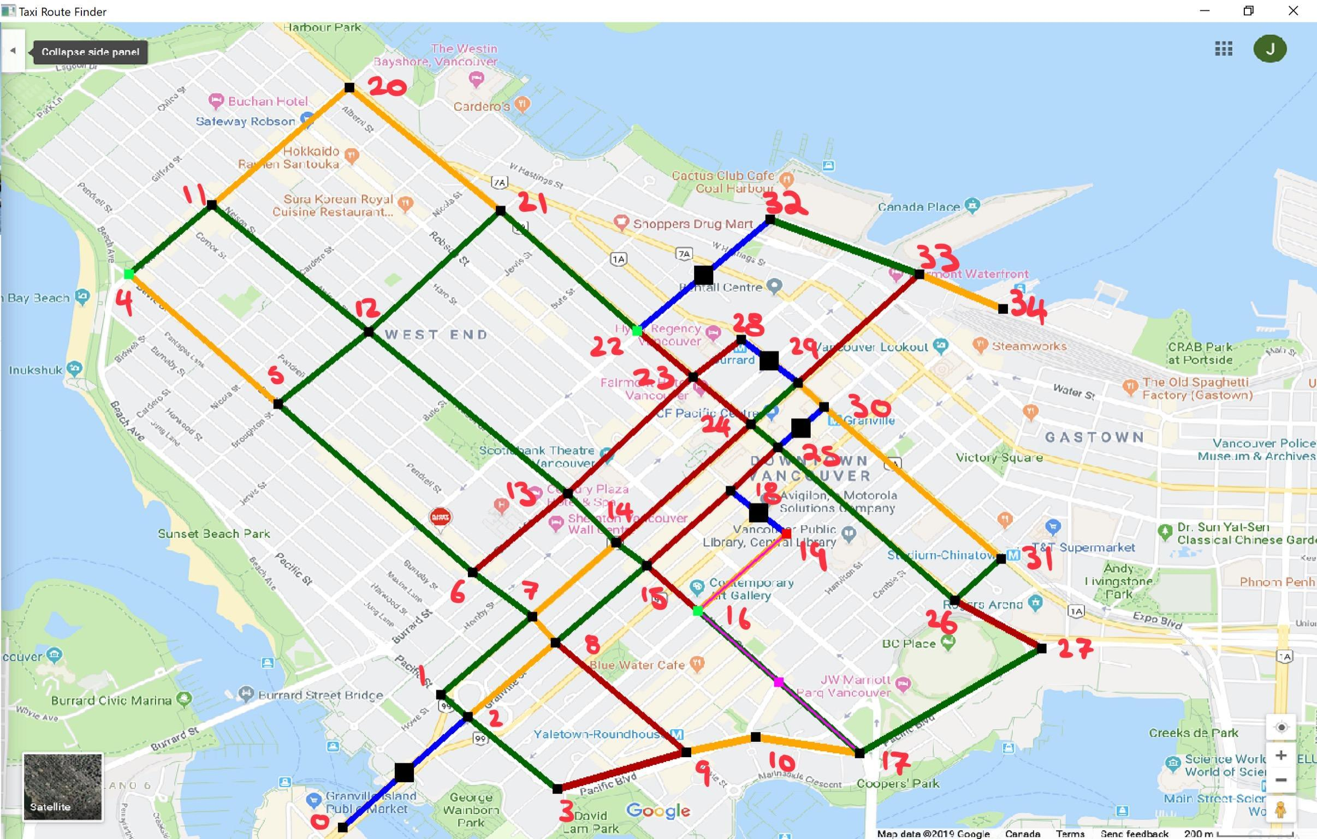

1. Simulated map of Vancouver

When the decision agent is at a node, it is given information about the presence of a passenger, the destination of the passengers, the connected nodes as well as links and the twenty best possible routes to take. The twenty best possible routes to take are determined by Yen’s Algorithm which computes single-source K-shortest loopless paths for a graph with non-negative weighted links. It is our objective to make the decision agent choose the best route to take out of the given twenty suggested from Yen’s Algorithm, rank the best route from the choices with our utilities in mind and take the path which will maximize the user’s utilities.

The utilities are dynamically recalculated each time the decision agent moves through each node. The starting node in the network is assumed to always be the Granville Island Public Market. Given the starting node where the decision agent starts the trip, the decision agent is informed with the list of destinations to visit in order such as passengers to pick up and passenger drop-off destinations. It can be seen that in Figure 4, the decision agent is highlighted in pink. The decision agent travels along the links we have assigned along the chosen route to pick up or drop off passengers. If a passenger is available to pick up at a node, the node is highlighted in green. If the node is a destination of a passenger inside the vehicle, the node is highlighted in red.

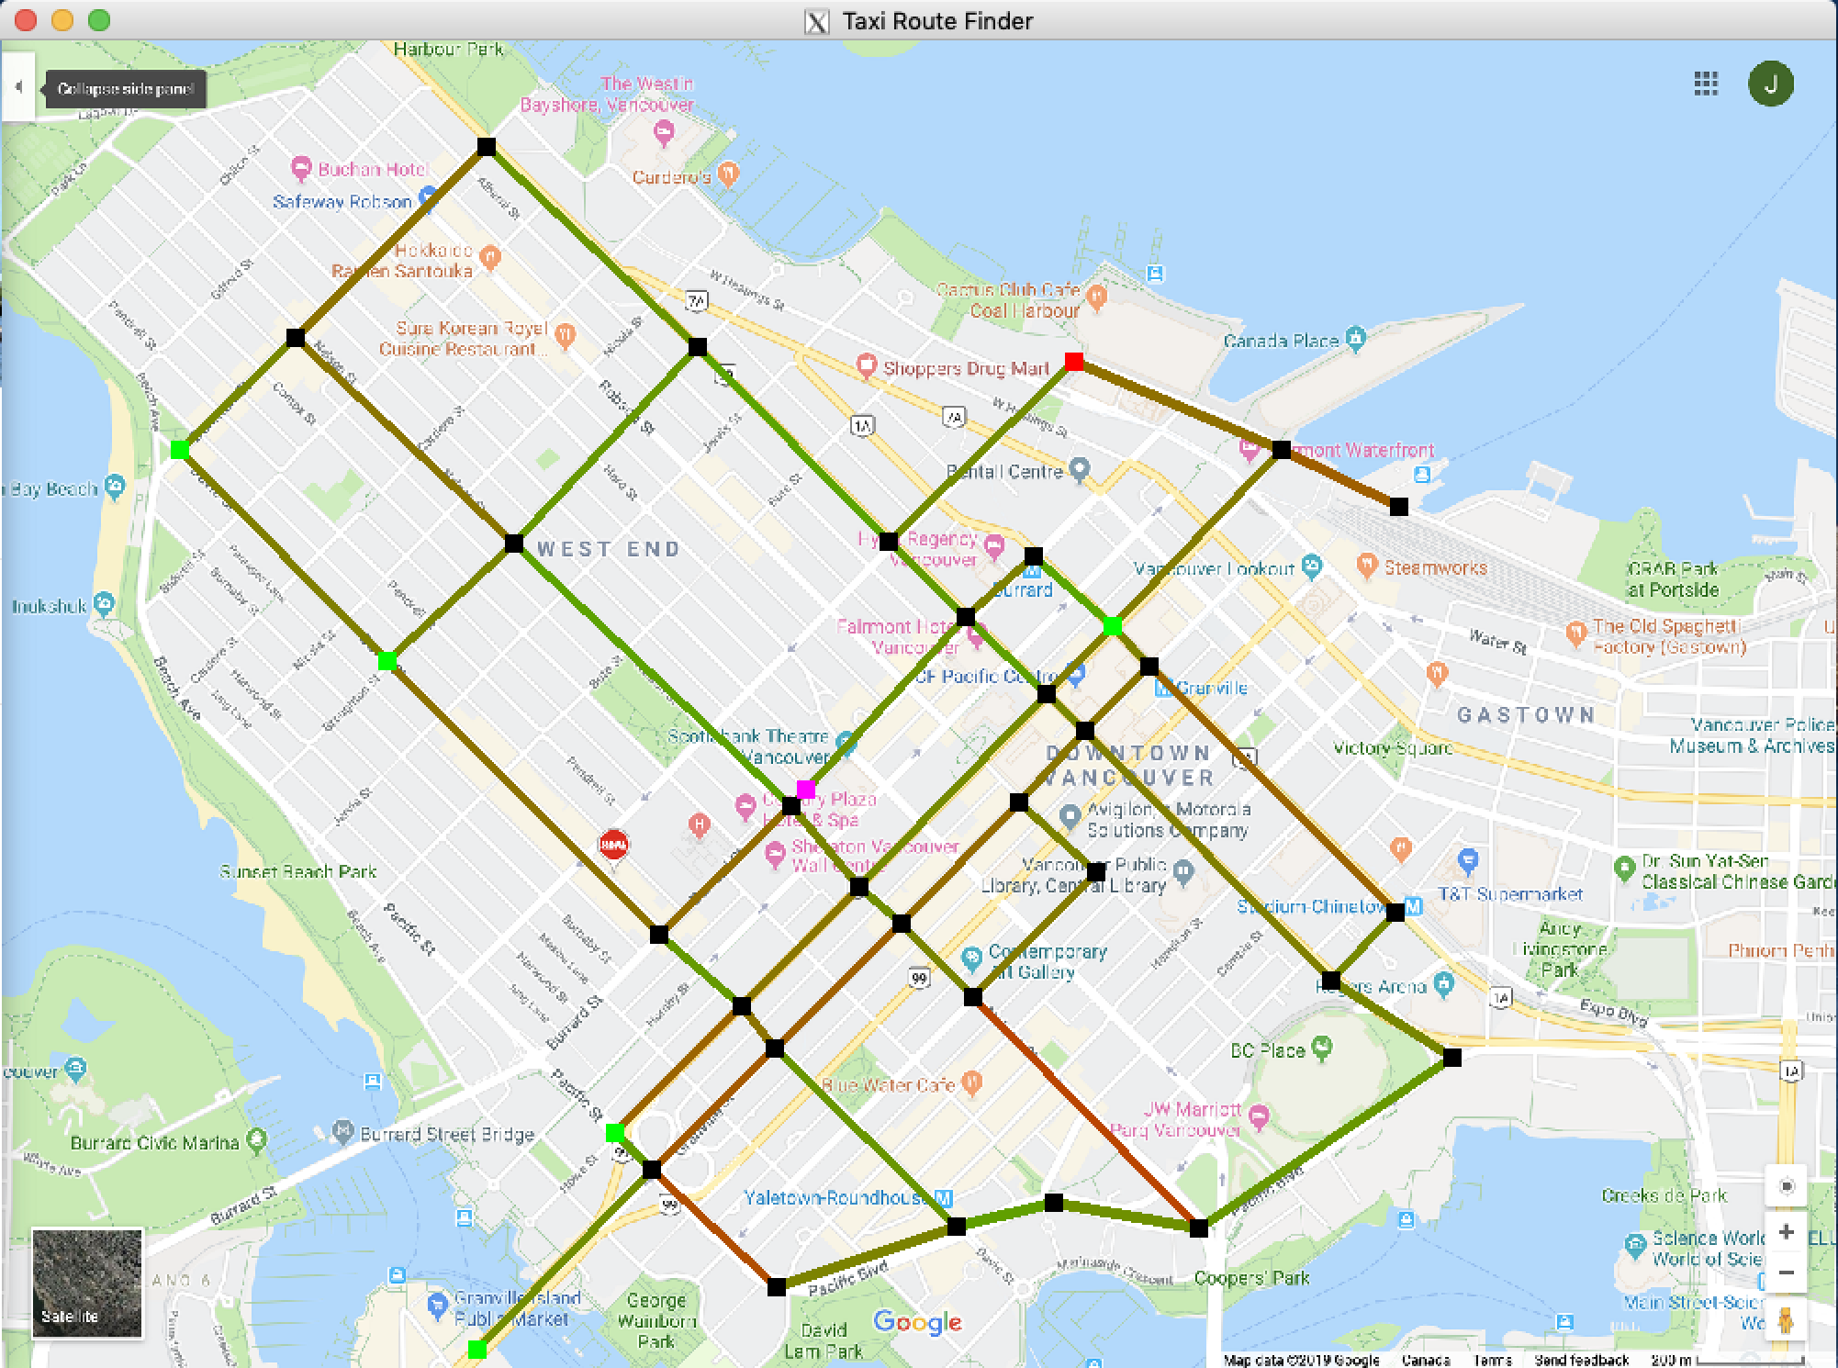

1. Simulated map of Vancouver with Decision Agent and Destinations

Along with the changes in nodes, we have clearly highlighted the appropriate links to show accidents and traffic that occur in the links. In Figure 5, it can be seen by the user that the links that are highlighted in a dark shade of red means there is heavy traffic whereas the links that show a brighter shade of yellow represent lighter traffic conditions with green representing ideal conditions (no traffic). The links that are highlighted in blue with a black square show that there has been an accident in that link and the decision agent will take that into account when making his decision based on his utility values.

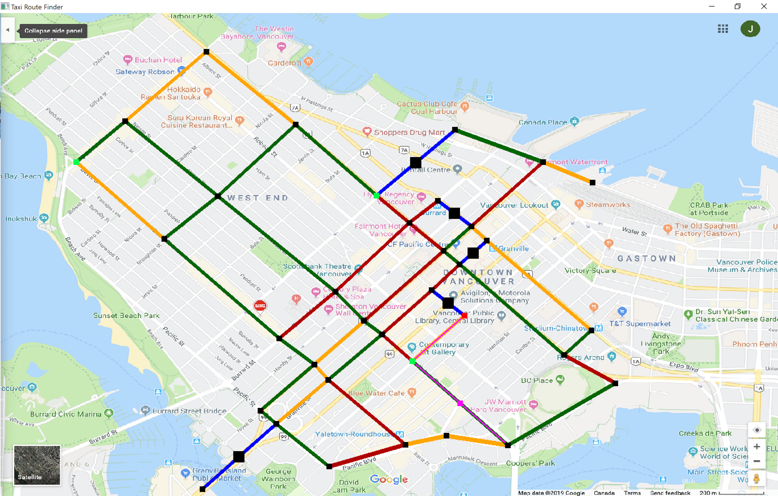

1. Simulated map of Vancouver with Decision Agent, Destinations, Accidents and Traffic

# Execution Process

We designed and implemented a route-finding decision agent that can navigate a network of connected nodes, while picking up and delivering passengers and avoiding undesirable road conditions. The decision agent is given information about its environment such as the network layout, travel times, and nearby road conditions. We assigned utility to path based on distance, possible traffic, passenger pick up, or destinations along the way, and the probability of accidents.

A. Distance Utility

We consider travel distance, because the agent has to decide which paths would be the fastest and shortest paths. We assigned weights in each links using vectors to provide approximate time it takes to travel from one node to another. Our taxi route finder program calculates N possible paths from current node to destination node, ranked from shortest to longest static distances using Yen’s Algorithm. Yens algorithm is a way of finding the N shortest paths in a nodal network. Works by repeatedly using a shortest path algorithm such as Dijkstra's algorithm, but removing links from the shortest path to find the next shortest paths [5]. We used this algorithm to determine the shortest paths between destinations. We found an implementation of Yen’s Algorithm in C++ online, and modified it to meet our requirements. The length of each possible path is multiplied by -2, and is assigned as the distance utility for the path.

B. Traffic Utility

Traffic is also an important factor when it comes to decision making of the agent. Our traffic values are implemented using a Markov Chain, as seen in Figure 6.

Each link in the network is assigned a state of either high, medium or low traffic. Initially all links are assigned low traffic. Each link is also assigned the probabilities of transitioning from one state to another, or staying at its current state. The decision agent can use these transition probabilities and the current state of the link to calculate the probability that the link will have high, low or medium traffic when it needs to cross that link. The decision agent then multiplies these probabilities by a static weight, -60 for high traffic, -30 for medium traffic, and -10 for low traffic, and adds resulting products to assign that link a utility value. The sum of the utility values for all links in a possible path is multiplied by -1, and assigned as the traffic utility for that path.

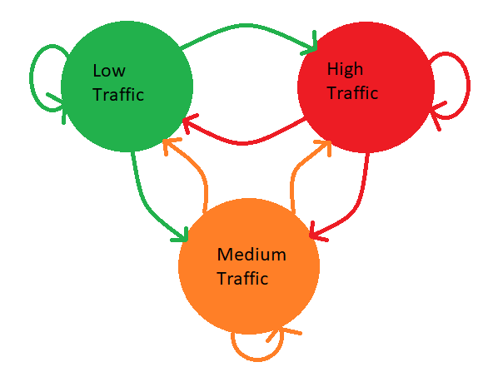

Fig. 6. Markov Chain Transition Diagram for Traffic Values

C. Passenger Utility

Passenger pick up utility is a factor we cannot miss since we are implementing a ride-share taxi to reduce the cost. The agent also has to decide if it can pick up additional passengers on the way to the current destinations and if the taxi route finder has enough rooms to fit the people along the way. We made the taxi so it can fit up to six people, so the agent should make a decision whether to pick-up/drop-off passengers along the way. For each node in a path, the probability of a passenger appearing at that node is added to find the total probability of encountering a passenger on that route. The utility from passengers in a path is assigned by multiplying this total probability of an accident by a dynamic weight that changes based on the current number of passengers the decision agent is carrying. The weight calculated using the formula:

$W=(1-\frac{P}{6})*40$

Where W is the weight, and P is the number of passengers the decision agent is carrying. This allows the utility to change from 40 when the agent is not carrying any passengers, to 0 when it is carrying 6 passengers and cannot pick up any more.

D. Destination Utility

Passenger and Destination Utilities are strongly correlated since the agent needs to decide whether to drop off or pick up passengers on the way while calculating the distances of each destination of passengers. If the agent thinks if second passenger’s destination is along the way of the first passenger, the agent decides to drop off the second passenger first before moving on to the first destination. For example, when the cab is full, the agent must decide to drop off passengers to the next destinations before picking up new passengers. The utility from destinations is calculated similarly to the utility for picking up passengers. For each path, the decision agent keeps count of how many nodes are a destination node. This count is multiplied by a dynamic weight that changes based on the number of passengers the decision agent is currently carrying. The weight is calculated using the formula:

$W = \frac{P}{6}*80$

Where W is the weight, and P is the number of passengers the decision agent is currently carrying. This weight varies from 80 when the decision agent is carrying 6 passengers, to 0 when it is carrying none.

E. Accident Utility

We have considered the possibility of accidents, or any other sort of blockade that makes traversing a link difficult. This implementation was similar to traffic, using a markov chain with probabilities for transition from the states accident and no accident, and for staying in its current state. The decision agent uses these probabilities and the current state of the link to calculate the probability that there will be an accident at this link when the decision agent need to cross it. The probabilities of an accident for all links in a possible path are added together to get the total probability of encountering an accident on that path, and multiplied by -100 to give the accident probability of the path.

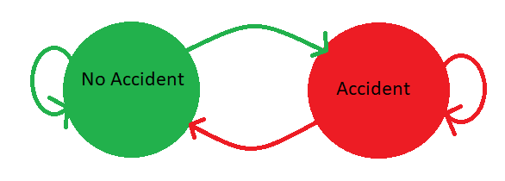

Fig. 7. Markov Chain Transition Diagram for Accidents

F. Total Utility

The total utility of a path found by considering the utility values for length, traffic, passenger pick-ups and drop-offs, and accidents. This is similar to using a decision matrix in decision theory, as shown in Table I. The total utility of a path can be found using a decision making rules such as minimax regret, or the principle of insufficient reason. For our implementation we multiplied the values by a weight as described above, and added them to find the total utility. The calculations for the individual utility values are shown in Table II. The possible paths are then ranked based on their total utility, and the best path is chosen for the decision agent to follow.

|  |  |  |  |  |  |
| --- | --- | --- | --- | --- | --- |
| Route | Distance | Traffic | Passenger | Destination | Accident |
| 1 |  |  |  |  |  |
| 2 |  |  |  |  |  |
| ... |  |  |  |  |  |
| 20 |  |  |  |  |  |

Table I. Decision Matrix of Utilities

|  |  |  |  |  |
| --- | --- | --- | --- | --- |
| Distance | Traffic | Passenger | Destination | Accident |
| -2*length | -60 $P_{High}$* +  -30 $P_{Medium}$*  +  -10 $P_{low}$* | $(1-\frac{P}{6})*40$ | $\frac{P}{6}*80$ | -100*P |

Table II. Table showing how to calculate the utility values where P means probabilities

Taxi route finder is simulated using OpenGL giving live information where and how the taxi is travelling. It is labelled in different colors guiding the users where the taxi would travel and how heavy the traffic is between nodes.

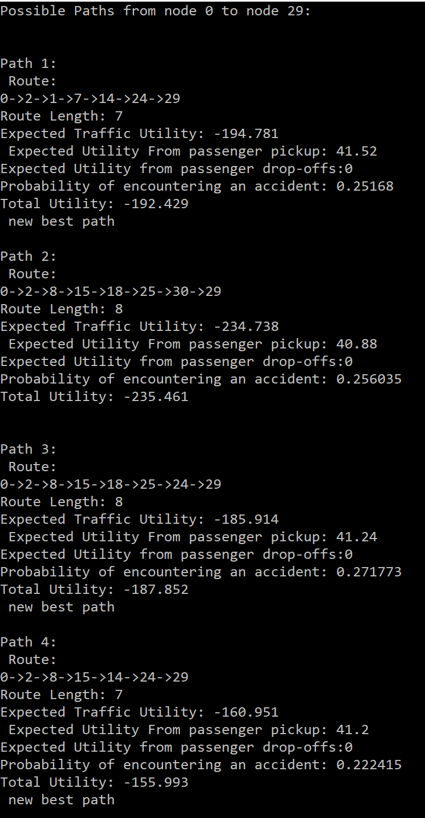

Fig. 8. Information on Utilities, shortest possible paths and total route length in debug mode

The program can run with/without debug mode. When run in debug mode, the user can view the possible paths the decision agent is considering and its utility values. The locations of nodes in the network can be seen in Figure 5. The program will use the number of the node when referring to it in the debug output. As shown in Figure 8, the decision agent is currently at node 0 and is attempting to pick up the passenger at node 29. For each possible path, we can see the sequence of nodes it is traveling, total route length, expected traffic utility, expected utility from passenger pick-up/drop-offs, and probability of encountering an accident. These utilities are multiplied by a weight assigned by the decision agent and added up to give the total utility of that specific route. When the program is run without debug mode, we can view continuous simulation of the agent as it travels across the city.

# Additional Future Applications and Improvements

For further development there are many general improvements that could be made to the code implementation to change the behavior of the network and decision agent, as well as additional features that could be added to enhance the real-world practicality of the simulation.

Without adding any additional features, there are many changes that could be made to the code to enhance both how the decision agent makes decisions based on its environment, and how the network behaves. One such change that would be fairly simple to implement would make each link bi-directional, with different dynamic parameters for traffic and accidents in both directions. Right now for ease of implementation and visualization the links in the network have the same values on matter which way the decision agent is traveling. Making this change would be fairly simple for the implementation, since the simulation already requires links in both directions for Yen’s algorithm. The visualization of this change in OpenGL would be more challenging, as is would be more difficult to indicate the traffic values in a certain direction, and which direction is blocked.

Another change that could be made is to change the weights used to calculate the utility, and change the decision rule used by the decision agent to further improve the behavior of the agent. The weights used for this implementation were based on what we wanted the decision agent to prioritize, and changed to improve the observed behavior. With the current weights, the decision agent first prioritizes getting to its destination with the lowest chance of high traffic and the lowest chance of encountering an accident. Due to the fact that the longer the path is, the higher the chance of encountering high traffic or an accident, this means the agent tends to take the shortest possible route unless an accident or high traffic appears. The agent then prioritizes additional passenger pick-ups and drop-offs depending on its current passenger load. This also means that the agent tends to only pick up the passengers closest to it, leaving passengers further out of the way for a long time before picking them up, or never picking them up. This behaviour could be changed by changing the weights or the decision rule used.

Similarly to changing the decision agents weights, the network probabilities could be changed to match clower the actual behavior of the streets in Downtown Vancouver that they represent. The current probabilities were chosen purely to demonstrate the features of the simulation, to show movement of the decision agent throughout the network. As such, many of the links have the same probabilities to encourage movement. To more closely model real-world situations, the probability value should be changed so some links have a much higher chance of high traffic or an accident thnt others. This would result in the decision agent consistently avoiding some links, instead preferring to take routes with lower traffic values. The probabilities of passengers at nodes could also be changed to show that some locations are busier than others, such as transit stations, or tourist locations. This would result in the decision agent trying to take routes that go through these busier locations to pick up more passengers..

In addition to changes to the current decision agent and network behaviors, we could also implement additional features to change the simulation as a whole. One such addition would be to allow for multiple decision agents to operate within the same network. This implementation would not be too difficult, as it only builds on the features we currently have. The decision agent is already stored in a structure that contains information on the agents current node, next node, and decision weights. To allow for multiple agents, we would only need to split the destination list between the agents, and coordinate which list a new destination gets added to when it is generated. Different decision agents could be given different behaviors and priorities by changing the weights or decision rule used, as explained earlier. Multiple agent could coordinate to spread out across the network and coordinate to increase the efficiency of passenger delivery.

Another feature that could be added would be that traffic values in one link could affect traffic values in nearby nodes. This would simulate real-world traffic conditions, where traffic can build up over several blocks. To simulate this we could make it so the traffic value in one link increases the probability of the same traffic value in nearby links. The decision agent would have to consider not only the traffic value and probabilities a link, but also the traffic values of nearby links when assigning a link utility based on traffic.

Another additional feature that could be added is a refueling node. In this implementation, the decision agent can only go a set static distance before it must refuel at a refueling node. The distance values have to be static values since it would be too complex to implement it with dynamically changing traffic conditions. We can implement the refueling node system which can stop by even if he has passengers and goes to the nearest gas stations to refuel when certain distance is met. The decision agent would have to keep track of how much further it can go, and how far away the nearest refueling node is when deciding on a route. Refueling a gas is one of the crucial factors when it comes to automobiles since it needs gas to move around the area to pick-up and drop-off passengers. Having refueling node would be useful and can lead the automobile to prevent further damages and unconditional stops while heading to the destinations.

Finally, we could add rush hour to our network simulation. We would implement rush hour by keeping track of execution time, and increasing the probability of high traffic during certain periods of execution time. The decision agent would be required to cluster the data on traffic to find which links are affected by rush hour and at what periods, and then take that into consideration when planning its route. Taking rush hour into the consideration is practical, because in the real world, there are rush hour in every city and setting the time to increase the traffic in certain roads would be useful.

In the near future, we would be sharing the road with autonomous vehicles. People would want self-driving automobiles with two main reasons namely: safety and economics. There have been more than a million accidents around the world in just a year. It is said that the main reason that caused the traffic fatalities are driver error [8]. Economically, consumers and businesses are likely to benefit from autonomous driving. It can save money and time in the long run.

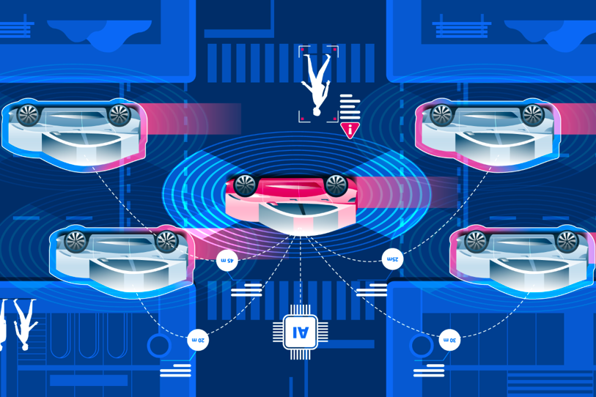

Fig.6. Driving autonomous vehicles forward with intelligent infrastructure (Adapted from [9])

# Conclusions

In conclusion, taxi route finder is a smart decision agent that can operate through a network of nodes, while picking up passengers, finding shortest paths along the way, and avoiding accidents that happened along the roads. As the agent goes through the nodes, it can gather more information about the traffic and update travel times and nearby road conditions. The decision agent can pick-up 6 passengers along the way to optimize the utility. The weight of the utilities change depending on the condition of the roads and the amount of passengers in the vehicle. We also added passengers and destinations to the node network, replacing set destination with a list of passengers to pick-up. The agent uses methods such as markov chains, utility assignment, decision rules, and shortest-path algorithms to navigate the network. The implementation of the taxi route finder was a success and is animated using OpenGL giving live information where the taxi would travel and highlights them.

The transition of manual driving to autonomous driving has already begun. The Automobile companies are already offering semi-automated cars with automatic safety features to reduce the accidents. Getting an autonomous taxi can change the world we live in.

##### References

1. Andy (2012) k_shortest_paths (version 2) [Source Code] https://www.technical-recipes.com/2012/the-k-shortest-paths-algorithm-in-c/
2. Dreyfus, S. (1969). “An Appraisal of Some Shortest-Path Algorithms”. Operations Research, 17(3), 395-412. Retrieved from http://www.jstor.org.proxy.lib.sfu.ca/stable/168375
3. Duque, D., Lozano, L., Medgalia, A. (2015) “An exact method for the biobjective shortest path problem for large-scale road networks”. European Journal of Operation Research, Volume 242, Issue 3, 788-797. Retreved from https://www-sciencedirect-com.proxy.lib.sfu.ca/science/article/ pii/S0377221714009072
4. Raith, A., Ehrgott M. (2009) “A comparison of solution strategies for biobjective shortest path problems”. Computers and Operations Research, Volume 36, Issue 4, 1299-1331. Retrieved from https://www-sciencedirect-com.proxy.lib.sfu.ca/science/article/pii/S0305054808000233
5. Yen, J. Y. (1970). An algorithm for finding shortest routes from all source nodes to a given destination in general networks. Quarterly of Applied Mathematics, 27(4), 526-530. doi:10.1090/qam/253822
6. Hussein, M., Sayed, T., Ismail, K., & Van Espen, A. (2014). Calibrating Road Design Guides Using Risk-Based Reliability Analysis. Journal of Transportation Engineering, 140(9), 04014041. https://doi-org.proxy.lib.sfu.ca/10.1061/(ASCE)TE.1943-5436.0000694
7. Möllering, K. (2007). A Markov-Chain Based Modeling Approach. Inventory Rationing, 83-96. doi:10.1007/978-3-658-24255-8_8
8. Spence, R. (2019, July 23). Everything to know about the future of self-driving cars - Maclean's. Retrieved from https://www.macleans.ca/society/technology/the-future-of-self-driving-cars/
9. Driving autonomous vehicles forward with intelligent infrastructure. (2019). Retrieved from https://www.smartcitiesworld.net/opinions/opinions/driving-autonomous-vehicles-forward-with-intelligent-infrastructure